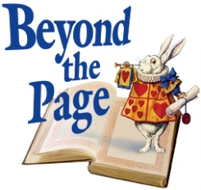
Beyond the Page has the following goals:
- Allow member libraries, both individually and collaboratively, to offer a rich variety of public humanities programming.
- Build upon already substantial collections and programs for patrons of all ages
- Craft new partnerships with humanists and humanities programs throughout the County
Annual efforts funded by the endowment yield will focus on these categories plus much more:
- Speaker’s Fund: Provide funds for a variety of library humanities programs at individual libraries, both in rural and urban areas.
- Major annual or biennial project: Create major collaborative initiatives that will involve all 27 libraries. For instance, a civil rights program involving speakers, common reading experience, and an oral history component.
- Summer library program: Increase the impact and reach of this ongoing program
- Mobile outreach: Provide humanities materials outside the library walls. Example: Humanities backpacks containing a collection of books and multimedia around a specific topic. Funding would also provide displays/booths promoting various collections to be taken to a variety of organizational events and cultural celebrations around the County.
- Traveling exhibits: Enable DCLS to "rent" and tour exhibits from national agencies, expanding outreach by displaying exhibits at multiple library venues.
- Lecture series: Encourage one or more libraries to create multiple-event lecture series.
- Marketing the humanities: Increase widespread awareness and participation by funding ongoing promotional materials that market humanities collections and support programs.

