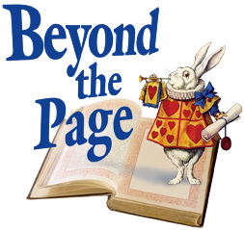
2016

Marketing Your Beyond the Page Event: Competitive and EZ Grants

Let us help you market your Beyond the Page event!
Information you provide will be used on our website and Facebook page:
http://www.beyondthepage.info/
https://www.facebook.com/beyondthepage

All information is for Public Viewing
Please send any/all of the following to Susie Engwall engwall@dcls.info.

- Event information
  - Title
  - Event Description
  - Date / Time / Location
  - Audience (Family, Toddler, Preschool, Elementary School, Middle School, High School, Adult, Senior Citizen)
  - Sponsoring Partners
  - Type of Event (Author Event, Book Discussion, Class/Workshop, Exhibit, Film Showing, Kids’ Event/Program, Lecture, Literary Event, Outreach Activity, Performing Arts, System-Wide Project, Teen Event/Program)
  - Presenter Information – name, website link, interview links…
  - Image for Event

- Facebook Posts- let us know when you’ve posted, we can share it
- Images- JPG or PNG format (individual images)
- Book Titles
- Videos
- Quotes
- Library Display images
- Articles
- Interviews- past or upcoming
- Image of the flier/poster – JPG, PNG or PDF format
- After event- send images and quotes from attendees

.

Website and Facebook administrators:
Susie Engwall engwall@dcls.info
Tracy Herold herold@dcls.info
Tana Elias telias@madisonpubliclibrary.org

