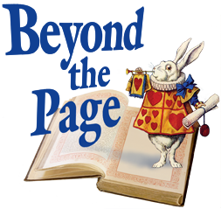
1/27/2017

INQUIRIES ABOUT GRANT APPLICATION:

- Organization/Businesses/Individuals may propose ideas for Beyond the Page grants to Dane County library staff for their consideration.

- All Beyond the Page grants will be planned and managed by a staff member at one of the 28 Dane County Libraries http://www.beyondthepage.info/libraries.

- Proposal guidelines are found at http://www.beyondthepage.info/Grants.

- Questions? Contact Tracy Herold herold@dcls.info.

