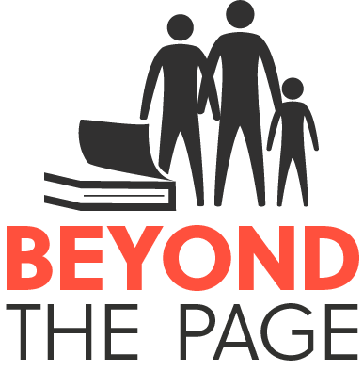
MARKETING TOOLKIT
You know your audience!

Please use this toolkit for inspiration as you plan your next Beyond the Page event.
Sponsor logos can be found at www.beyondthepage.info/grants.
Contact Susie Engwall (engwall@dcls.info) with questions.

Graphics/Tools
 | Who does it? | Need by? | Notes
Event Graphic- include event details and sponsor logos |  |  | Sponsors: BtP, Madison Community Foundation and National Endowment for the Humanities
Web Image
Web Image
8.5x11 poster
½ sheet flier
Bookmarks
Video Clips
Book List
Media List

Marketing
Partner/Sponsor Organization:
How are they marketing?
Facebook Page | Recognize and link to sponsors in your Facebook post

 | Who Does? | Need by? | Notes
Email blast
Facebook posts
Facebook event post
Library website
Library Twitter
Library Instagram
Library newsletter
Library display
TV Newscast
WI State Journal
Madison Times |  |  | madisontimes.events@gmail.com
Capital Times
Madison.com
calendar@Isthmus
Madison365.com
iHeart Radio
WORT
Channel3000.com |  |  | When submitting, scroll down to find free button
WPR- event calendar
WKNOW.com
Eventbrite.com
Brava Magazine
UMOJA Magazine
Community:
Newspaper
Newsletter
Facebook Page
Facebook Groups

Sample Facebook Posts/Tweets
 | Text | Graphic/Video | Posting Date
Facebook post #1

Linking to what?
Facebook post #2

Linking to what?
Facebook Boost
Which post?
How much to spend?
Tweet #1

Tweet #1

