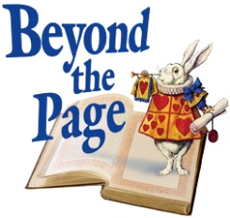
Beyond the Page Oversight Committee:

Beyond the Page will be administered by a revolving committee comprised of seven library staff and two or three community leaders from the humanities. Together this team will ensure programming of the highest order and fund collaborative work that benefits the entire system and Dane County population.

Name | Position | Email
Jim Ramsey | Chair | jramsey@midlibrary.org
Leah Fritsche | Vice-Chair | leah@deerfieldpl.org
Tracy Herold | Secretary | herold@dcls.info
Margie Navarre-Saaf | Member | mnavarre@madisonpubliclibrary.org
Elizabeth Zimdars | Member | elizabeth.zimdars@fitchburgwi.gov
Trudy Lorandos | Member | tlorandos@ci.verona.wi.us
Katharine Clark | Member | kclark@mcfarlandlibrary.org
Meg Turville-Heitz | Member | meg.turvilleheitz@wisconsinhumanities.org
Fabu | Member | fabu@artistfabu.com
Mark Fraire | Member | danearts@countyofdane.com

